- Employee Personal Information: Always check to ensure this information is accurate.
  - ID
  - Name
  - Address
  - Pay Period: The length of time for which an employee’s wages are calculated.

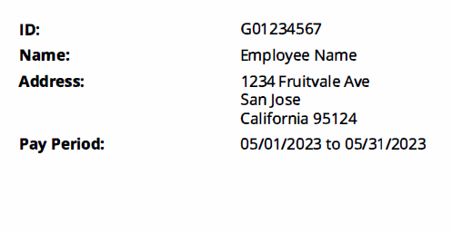

Payment Summary

  - Gross: Total amount of money earned during a pay period before deductions.
    - If an employee is on deferred or annualized pay (10-mo and 11-mo), the gross is the annual salary divided by 12 months.
    - Hourly employees calculate gross amount by multiplying the number of hours worked by the hourly rate.
  - Total Personal Deductions: Total amount of all taxes and deductions withheld from employee’s wages during the pay period.
  - Net: The amount of money left after all deductions have been withheld from the gross pay earned in the pay period.
  - Employer Contributions: Total amount of all taxes and deductions that the employer contributed during the pay period.


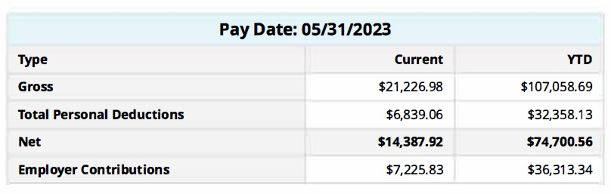
- Earnings: Wages paid to employees in return for labor or services.

  - Title: Employee’s position
  - Earnings: Identifies which type of earnings are being paid during the pay period.
  - Hours or Units: Time submitted via time sheet.
  - Rate: Hourly rate of pay
  - Amount: Gross wages
  - YTD: Total amount of wages paid during calendar year.

Please refer to the link below for more about the earn codes and deduction codes and payroll calendars.

Please just copy and paste the link below to your browser.


https://downloads.smccd.edu/browse/payroll?fo=%2Fsites%2Fdownloads%2FPayroll%2FShared%20Documents%2FDistrict%20Payroll%20Information&n=District%20Payroll%20Information

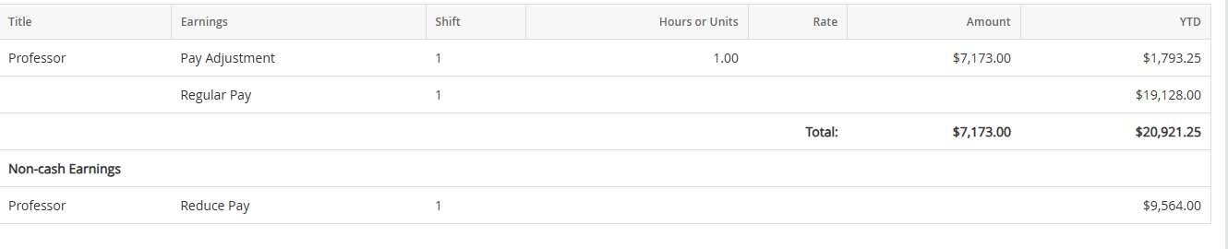

- Benefits, Deductions, and Taxes: The amount of money subtracted from the gross pay earned for mandatory taxes, employee medical/dental benefits, and/or retirement benefits.

  - Deductions before Federal Tax: Deductions in this category are pre-tax withholdings.
    - Insurance: Medical, Dental, Vision
    - Retirement: PERS, STRS DB & CB
    - Supplemental Retirement Plans: 403(b) and/or 457 plan
    - Flexible Spend

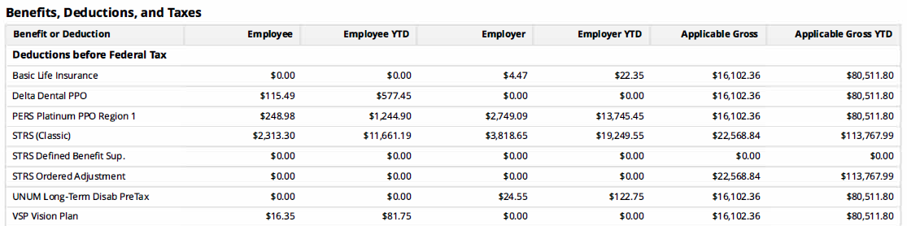

Taxes
    - FICA Medicare: Mandatory payroll tax of 1.45% applied to the gross income, with the employer matching the contribution made by employee.
    - Additional Medicare: An extra 0.9% tax on earned income exceeding $200,000.00.
    - CA State Tax: Tax imposed by the state of California that is withheld by the employer from employee’s earned wages.
    - CA Unemployment Insurance: Tax paid by employer to provide temporary assistance to qualify unemployed workers.
    - Federal Withholding Tax: Tax imposed by the federal government that is withheld from employee’s earned wages. The amount withheld depends on two factors: the amount of money earned, and the information provided on Form W-4.
    - FICA Old-Age, Survivors, and Disability Insurance tax also known as Social Security Tax of 6.2% applied to the gross income, with the employer matching the contribution made by the employee.

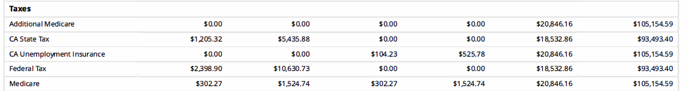

  - Deductions after Federal Tax: Deductions in this category are post-tax withholdings.
    - Child Support & Garnishments
    - Roth 457 & 403b
    - Member union due fees
    - Voluntary Deductions
    - Worker’s Compensation: Insurance paid by the employer that provides cash benefits and/or medical care for workers who are injured due to a work-related accident.

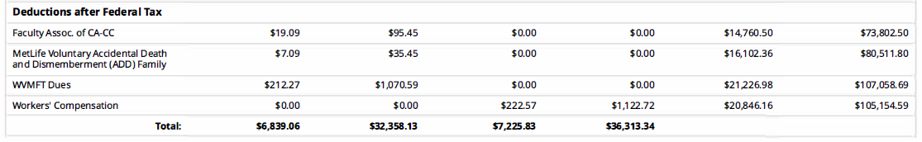

- Check or Direct Deposit: Identifies type of payment made to employee and the financial institution information.

