International Student $50 Application Fee Credit/Debit Card Form

Select college and fax or mail the completed form to the International Student Program Office listed below.
□ Cañada College □ College of San Mateo □ Skyline College
4200 Farm Hill Blvd. 1700 W. Hillsdale Blvd. 3300 College Drive
Redwood City, CA 94061 San Mateo, CA 94402 San Bruno, CA 94066
Fax: (650) 381-3518 Fax: (650) 574-6166 Fax: (650) 738-7140
caninternational@smccd.edu csminternational@smccd.edu skyinternational@smccd.edu

Student’s Name: ____________________________________________________________________________
^{Family/Last Name} ^{Given/First Name}

Semester Applying For: Fall Spring Year: ___________________
Card Type: Visa MasterCard Discover American Express
If you are using a Visa, MasterCard or Discover, please provide the 3-digit security code found on the back of your card.
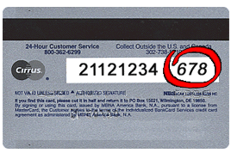

The card security code for your American Express card is a
4-digit number located on the front of your credit card, to the right or left above your main credit card number.

Card Number: ________________________________________________
Expiration Date: __________________________________
Security Code: ____________________________________
Print name as it appears on card:_______________________________________
Cardholder Billing Address: __________________________________________
^{Number and Street}
__________________________________________________________
City, Province, Country, and Postal Code
Cardholder Telephone Number:____________________________________

Signature: __________________________________________________
By signing this form, I agree to have US $50 application fee charged to my credit/debit card.
Date: _____________________________

